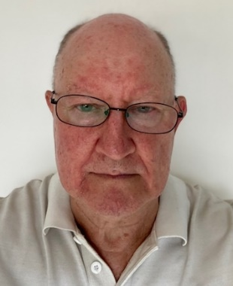
Iain Mowatt is a founding member of the HK Temporary Works forum. Iain is a civil engineer with many years’ experience in construction in project management and Temporary works. He is a hands-on construction professional with a passion for modularisation, MMC, DfMA and digital transformation.
Iain came to HK in 1979 and worked on many of HK’s leading projects, the Tsing Ma and Kap Shui Mun Bridges, the T1 terminal at Chek Lap Kok in the 80’s and 90’s. He joined Gammon Construction in 2011 working on West Kowloon Terminus then transferred Lambeth Associates, the in-house consulting engineers for Gammon. He introduced many of the modular systems that are today common features on Gammon sites.

