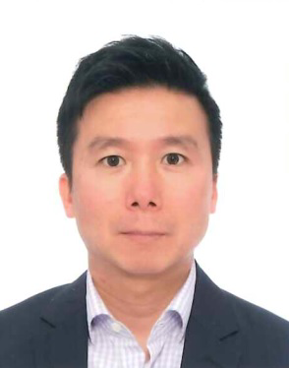
Henry is a civil and geotechnical engineer with over 25 years of experience in large-scale, high-rise building developments and multidisciplinary infrastructure projects. Henry had worked with ARUP for over 20 years before he became the Managing Director of Fugro (HK) Ltd. between 2018 and 2021. He is currently the Managing Director of HSP Consulting Co. Ltd. and a Director of Goldwave Steel Structure Engineering, a steel specialist contractor. Henry’s professional qualification include Registered Professional Engineer (RPE) and Registered Geotechnical Engineer (RGE).

