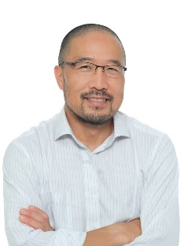
David Sein graduated from the University of Melbourne in 1995. He worked on civil engineering projects in Canada and then moved to Hong Kong in 1997 where he cut his teeth at C M Wong and Associates Limited designing and delivering private sector and Housing Authority foundation projects, as well as Landslip Preventative Measures contracts. In 2001, David moved to Gammon Construction Limited where he established and lead the substructures and tunnelling design group and designed and managed temporary works on large scale civil engineering projects as well as spending several years on site. David joined Leighton Asia in 2014 as Engineering Manager contributing several years at the delivery end embedded in the Contractor's engineering team on site. He is now stationed in Leighton's Head Office leading Engineering across the business. David is a chartered engineer in the civil and geotechnical disciplines. David was responsible for drafting the HK-TWf publication “Control and Management of Temporary Works” and he has a keen interest to improve temporary works safety from a contractor’s perspective.

