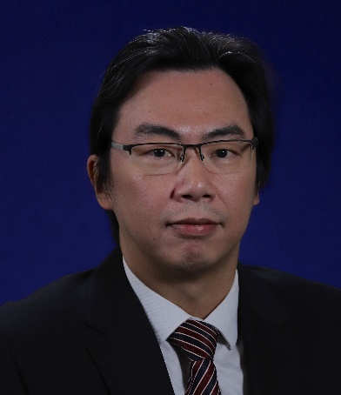
Chris Cheng is General Manager of Lambeth Associates Ltd, the in-house engineering consultancy of Gammon Construction Ltd. Before joining Gammon in 2010, he was Technical Director in design consultants, including Hyder and Meinhardt. He is also a Registered Structural Engineer in Hong Kong since 2004. Chris has over 27 years of extensive construction and design experience in all aspects of projects. Chris is an enthusiastic promoter of DfMA/MiC construction and engineering for safety.

