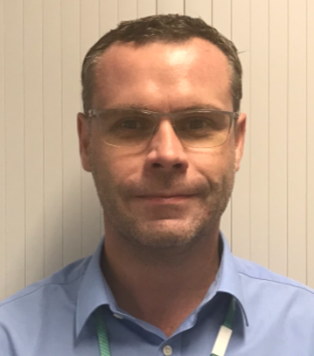
Mark McGleenon is a Senior Project Manager at China State Construction Engineering (Hong Kong). Prior to joining China State Construction Engineering (Hong Kong) he was a Senior Manager at the Airport Authority Hong Kong involved in the construction of the Third Runway Project. Previously he worked for the MTR Corporation on the West Island Line Extension and the High Speed Rail West Kowloon Terminus projects. Mark is a Chartered Engineer and Member of the Institution of Civil Engineers since 2007. Before coming to Hong Kong Mark worked for a number of leading Civil Engineering Contractors in the UK and has over 25 years’ experience across the Highways, Rail, Building and Waste Water sectors including a period working as an in house Temporary Works Design Engineer.

